**. JOSEPH’S COLLEGE OF ARTS & SCIENCE (AUTONOMOUS)**

**CUDDALORE-1**

**PG Department of Computer applications**

**Report on DHAMAKA 2K23**

Title of the Programme: DHAMAKA 2K23

Date : 21.09.2023

Venue : . Joseph’s college of arts & science (autonomous)

Cuddalore-1

The PG Department of Computer Applications organized an Intra-Collegedepartmental competition named "**DHAMAKA 2K23**" on 21.09.2023, from 9:30 AM to 5:00 PM. This event saw enthusiaic participation from udents of various departments of our college with the maximum participation of 150. The competition aimed to unite udents from various departmentsto demonrate their technical prowess, imulate innovation, and promote collaboration among young technologis. All eventsprovided udents with a valuable platform to present and be recognized for their exceptional technical solutions. Activities organized are ***Connection, Dumb chardes,AD’S Craze,and sudoku.***

.

**Organizing Secretaries**

**Invitation**

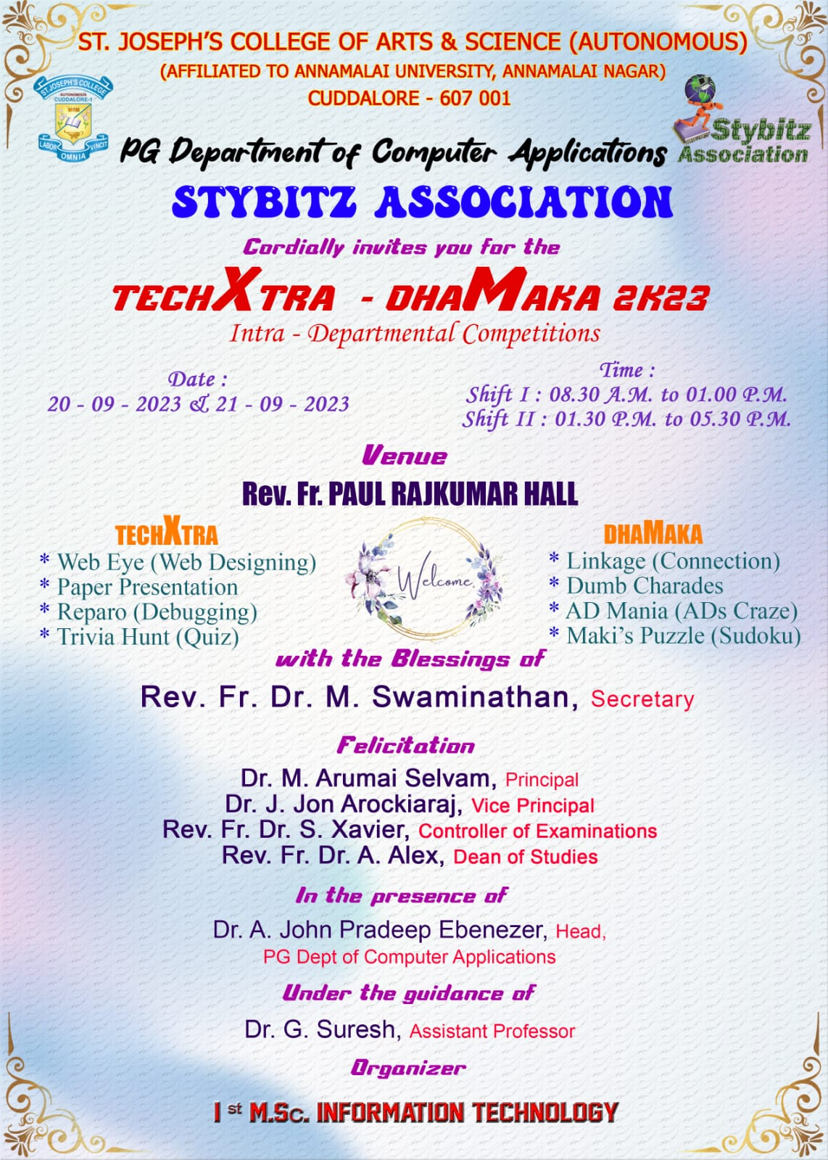

Banners

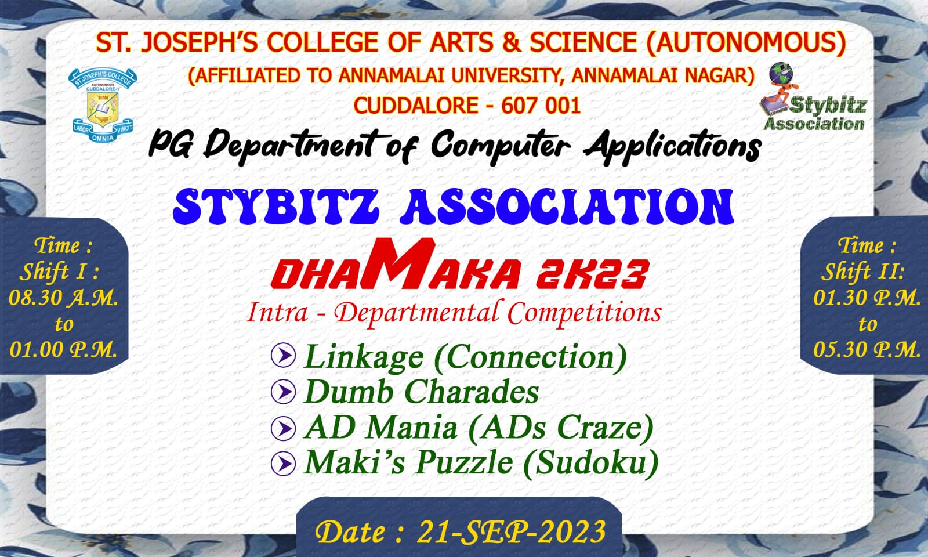

Photos

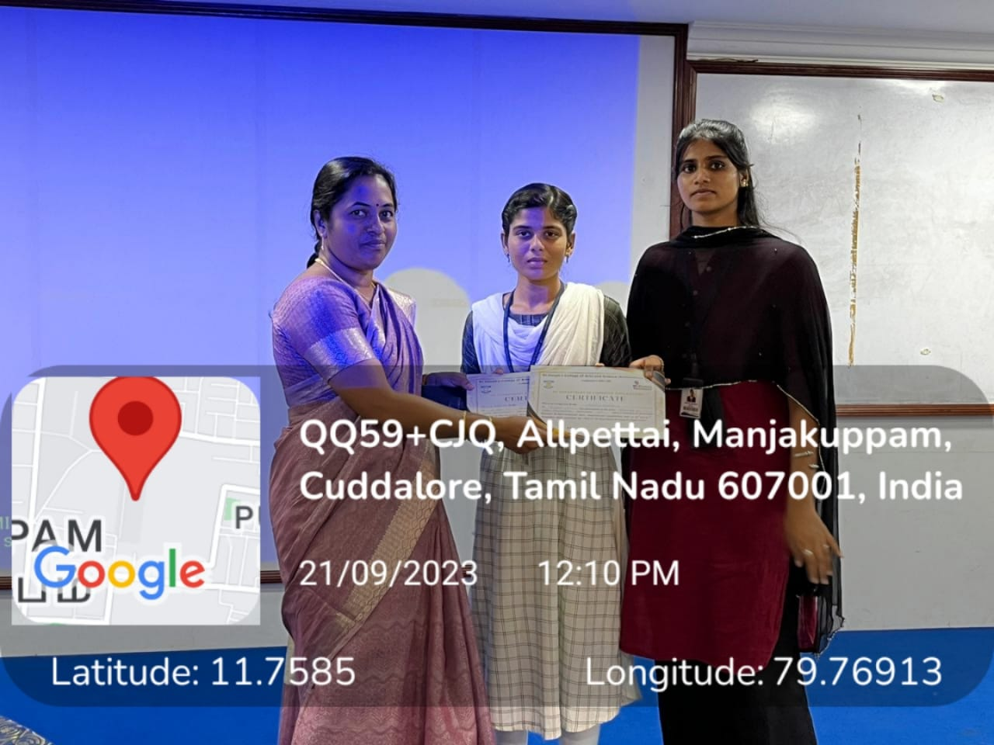

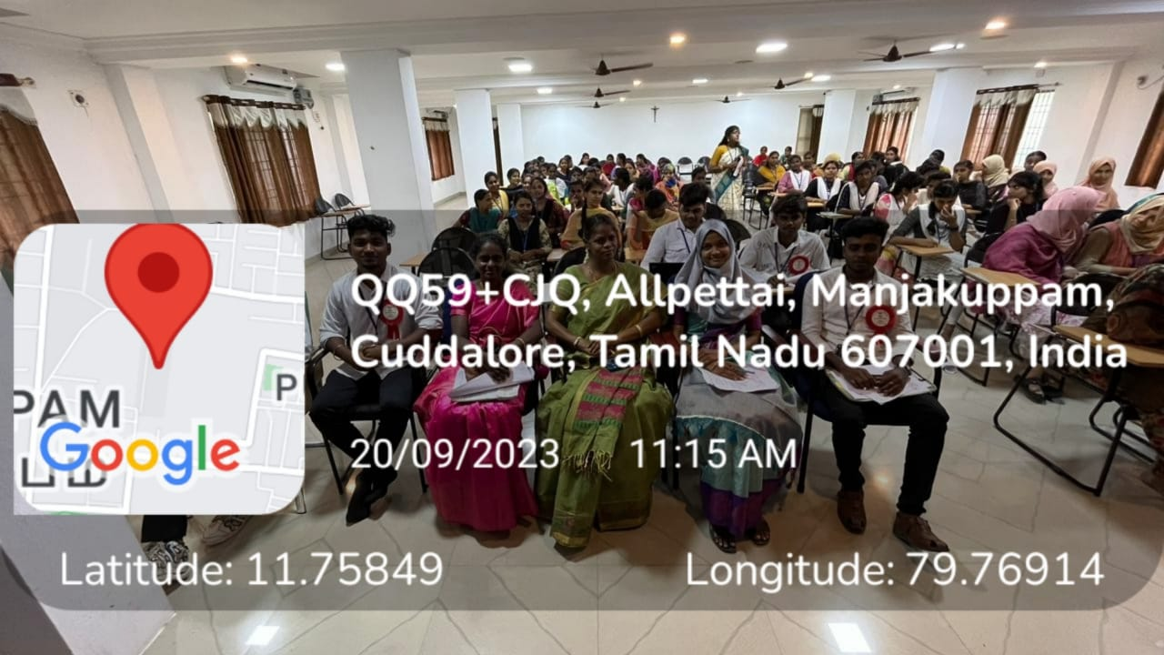

Certificate

Participatoin list

|  |  |  |
| --- | --- | --- |
| S.No | NAME | CLASS |
|  | Ayanash.R | 1 BCA-A |
|  | KeerthiS.K | 1 BCA-A |
|  | Babu.K | 1 BCA-B |
|  | Dhamu.S | 1 BCA-B |
|  | Gowtham Raja.R | 11 BCA-A |
|  | KoushikS.P | 11 BCA-A |
|  | Nithesh.S | 11 BCA-B |
|  | ThinakaranK | 11 BCA-B |
|  | AbdualRahamanM | 111 BCA-A |
|  | GowthamVishva K | 111 BCA-A |
|  | GokulM | 111 BCA-B |
|  | AkashS | 111 BCA-B |
|  | SitharasanS | 1 BBA(CA) |
|  | Sajan .G | 1 BBA(CA) |
|  | Sham Jenish.A | 11 BBA(CA) |
|  | Sudarsan .V | 11 BBA(CA) |
|  | Mohammed ThoufikT | 111 BBA(CA) |
|  | Abivosu.E | 111 BBA(CA) |
|  | Praveen Kumar A | 1 BCA-A |
|  | Balaji P | 1 BCA-A |
|  | KaviarasanS | 1 BCA-B |
|  | Dhinesh Kumar S | 1 BCA-B |
|  | PragadeeshK.G | 11 BCA-A |
|  | Abdul Rahman A | 11 BCA-A |
|  | Krishna AnandS | 11 BCA-B |
|  | ChandruB | 11 BCA-B |
|  | ThamiySelvanM | 111 BCA-A |
|  | Dhanush D | 111 BCA-A |
|  | ArunM | 111 BCA-B |
|  | Andrew Ferdinand S | 111 BCA-B |
|  | Manoj S | 1 BBA(CA) |
|  | Sachin Kumar S | 1 BBA(CA) |
|  | SelvamK | 11 BBA(CA |
|  | Siva Raman V | 11 BBA(CA |
|  | ManikandanS | 111 BBA(CA) |
|  | Mohammed Imran E | 111 BBA(CA) |
|  | ThiyaneshN.K | 1 BCA-A |
|  | Ranjith M | 1 BCA-A |
|  | Ragul T | 1 BCA-A |
|  | Sathish Kumar D | 1 BCA-A |
|  | Chandran K | 1 BCA-A |
|  | Imran Khan N | 1 BCA-B |
|  | RakshithR | 1 BCA-B |
|  | Bhuvaneshwar A | 1 BCA-B |
|  | Saranrajan V | 1 BCA-B |
|  | NarasDeen F | 1 BCA-B |
|  | SathiyaR | 11 BCA-A |
|  | PratheshJ | 11 BCA-A |
|  | Naresh M | 11 BCA-A |
|  | Gowtham P | 11 BCA-A |
|  | Sham B | 11 BCA-A |
|  | SayedAfsarA | 11 BCA-B |
|  | Abdul AhamedK | 11 BCA-B |
|  | Ilayavan M | 11 BCA-B |
|  | Prem Kumar S | 11 BCA-B |
|  | ManiMaran G | 11 BCA-B |
|  | ThamizhSelvanM | 111 BCA-A |
|  | Abdul Rahman M | 111 BCA-A |
|  | AkashArun A | 111 BCA-A |
|  | Akash M | 111 BCA-A |
|  | Sri Jaya SimmaNithi V | 111 BCA-A |
|  | Inba Guru V | 111 BCA-B |
|  | Mohammed AsjathM | 111 BCA-B |
|  | Mohammed Fasil M | 111 BCA-B |
|  | Gowthaman V | 111 BCA-B |
|  | Riyazulla S | 111 BCA-B |
|  | MadhavanP | 1 BBA(CA) |
|  | SuriyaT | 1 BBA(CA) |
|  | Martin J | 1 BBA(CA) |
|  | Ulaganathan M | 1 BBA(CA) |
|  | Bhathmasri M | 1 BBA(CA) |
|  | BuvaneshR | 11 BBA(CA) |
|  | Darwin samC | 11 BBA(CA) |
|  | Naveen M | 11 BBA(CA) |
|  | Rakesh S | 11 BBA(CA) |
|  | Vishnvarathan K | 11 BBA(CA) |
|  | SelvaganapathyR | 111 BBA(CA) |
|  | Riyaz B | 111 BBA(CA) |
|  | Vishnu Ravi B | 111 BBA(CA) |
|  | Dhinesh raj M | 111 BBA(CA) |
|  | Praveen N | 111 BBA(CA) |
|  | Krishna Kumar V | 1 BCA-A |
|  | Deva Prakash A | 1 BCA-A |
|  | GokulrajD | 1 BCA-B |
|  | DharanishunP | 1 BCA-B |
|  | Anandha Kumar P | 11 BCA-A |
|  | Gowtham Raja R | 11 BCA-A |
|  | VishvaM | 11 BCA-B |
|  | AbineshS | 11 BCA-B |
|  | Balaji.B | 111 BCA-A |
|  | SaiPrasanna.K | 111 BCA-A |
|  | Ashwinraj.M | 111 BCA-B |
|  | Mohammed Aman.A | 111 BCA-B |
|  | Abdul Rahman.A | 1 BBA(CA) |
|  | Oppilamani.K | 1 BBA(CA) |
|  | Tamilarasu.M | 11 BBA(CA) |
|  | Mohamed Thaahir.M | 11 BBA(CA) |
|  | Gaffer Shariff.A | 111 BBA(CA) |
|  | Surendhar.K | 111 BBA(CA) |
|  | Dhivya.S | 1 BCA-A |
|  | Rajasri.S | 1 BCA-A |
|  | Gokulsri.M | 1 BCA-B |
|  | Kanishka.A | 1 BCA-B |
|  | Sridevi.S | 11 BCA-A |
|  | Subasri.K | 11 BCA-A |
|  | Mukisha.V | 11 BCA-B |
|  | Sharmila.S | 11 BCA-B |
|  | Anbuselvi.S | 111 BCA-A |
|  | Rajasri.R | 111 BCA-A |
|  | Nanthini.G | 111 BCA-B |
|  | Varsha.K | 111 BCA-B |
|  | Lakshmi.C | 1 BBA(CA) |
|  | Prishiya.R | 1 BBA(CA) |
|  | Kaviya.N | 11 BBA(CA) |
|  | Ezhilarasi.E | 11 BBA(CA) |
|  | Mugunthamala.B | 111 BBA(CA) |
|  | Subanu.S | 111 BBA(CA) |
|  | Agalya.A | 1 BCA-A |
|  | Gayathri.P | 1 BCA-A |
|  | Gayathri.K | 1 BCA-B |
|  | Karthiga.S | 1 BCA-B |
|  | Hema.R | 11 BCA-A |
|  | Jresona Infant Mary.D | 11 BCA-A |
|  | Ramya.S | 11 BCA-B |
|  | Anitha.S | 11 BCA-B |
|  | Janani.M | 111 BCA-A |
|  | Vaishnavi.D | 111 BCA-A |
|  | GhoseyaAkther.A | 111 BCA-B |
|  | Thrisha.K | 111 BCA-B |
|  | JeyasriV | 1 BBA(CA) |
|  | .DhanamiS | 1 BBA(CA) |
|  | JesimaBanuA | 11 BBA(CA) |
|  | Banu.S | 11 BBA(CA) |
|  | JensiyaR | 111 BBA(CA) |
|  | Najimma.M | 111 BBA(CA) |
|  | Harishni | 1 BCA-A |
|  | Avanthiga | 1 BCA-A |
|  | Devi | 1 BCA-A |
|  | Lithiga | 1 BCA-A |
|  | Harina | 1 BCA-A |
|  | RamyaS | 1 BCA-B |
|  | MadhumithaA.S | 1 BCA-B |
|  | Sivaranjini R.T | 1 BCA-B |
|  | Saruvathini P | 1 BCA-B |
|  | Mahalakshmi S | 1 BCA-B |
|  | SithikaS | 11 BCA-A |
|  | AbinayaM | 11 BCA-A |
|  | Madhumitha P | 11 BCA-A |
|  | FarhathSulthana A | 11 BCA-A |
|  | Arthi A | 11 BCA-A |
|  | Subeshna P | 11 BCA-B |
|  | Lakshmi Shree S | 11 BCA-B |
|  | Bharathi T | 11 BCA-B |
|  | Janani S | 11 BCA-B |
|  | Shagidha M | 11 BCA-B |
|  | SangeethaT | 111 BCA-A |
|  | Amirtha V | 111 BCA-A |
|  | Ishwarya S | 111 BCA-A |
|  | Narmatha M | 111 BCA-A |
|  | Haridhaarani S | 111 BCA-A |
|  | Madhumitha A | 111 BCA-B |
|  | Leena S | 111 BCA-B |
|  | Dharshini N | 111 BCA-B |
|  | Subashree M | 111 BCA-B |
|  | Prethishta P | 111 BCA-B |
|  | Dharashini.P | 1 BBA(CA) |
|  | Dharashini.P | 1 BBA(CA) |
|  | Nirosha M | 1 BBA(CA) |
|  | Harshitha S | 1 BBA(CA) |
|  | Subathra S | 1 BBA(CA) |
|  | Farzana Praveen M.R | 11 BBA(CA) |
|  | Hemapriyadharshini S | 11 BBA(CA) |
|  | vinishiya M | 11 BBA(CA) |
|  | Sindhuja R | 11 BBA(CA) |
|  | Sindhuja V.J | 11 BBA(CA) |
|  | Ranjini R | 1 BCA-A |
|  | Hindhuja R | 1 BCA-A |
|  | Thansira R | 1 BCA-B |
|  | Somapriya M | 1 BCA-B |
|  | Nabila S | 11 BCA-A |
|  | Benciya Glory A | 11 BCA-A |
|  | sharmila S | 11 BCA-B |
|  | Sridevi P.S | 11 BCA-B |
|  | Avina V | 111 BCA-A |
|  | Ravithra H | 111 BCA-A |
|  | LalithaK | 111 BCA-B |
|  | Dhivya R | 111 BCA-B |
|  | Namitha K | 1 BBA(CA) |
|  | Aysha Bee S | 1 BBA(CA) |
|  | Dhanalakshmi S | 11 BBA(CA) |
|  | supraja K | 11 BBA(CA) |
|  | Abinaya I | 111 BBA(CA) |
|  | Swetha K | 111 BBA(CA) |